CUSTOM BOOTCAMP
Azure Containers

Docker Containers
- Docker is a set of platforms as a service (PaaS) product that use the Operating system level virtualization to deliver software in packages called containers.
- Containers are isolated from one another and bundle their own software, libraries, and configuration files; they can communicate with each other through well-defined channels.
- All containers are run by a single operating system kernel and therefore use fewer sources.
- Docker Containers contain binaries, libraries, and configuration files along with the application itself.
- They don’t make a guest OS for each container and rely on the underlying OS kernel, which makes the containers lightweight.
- Containers share resources with other containers in the same host OS and provide OS-level process isolation.

Cloud Service Models
- IaaS – Infrastructure as a Service. Example: Virtual Machines
- PaaS – Platform as a Service Example: Azure SQL, Databricks, Cosmos DB
- SaaS – Software as a Service. Example: Office 365, Power BI Source, Dynamic 365

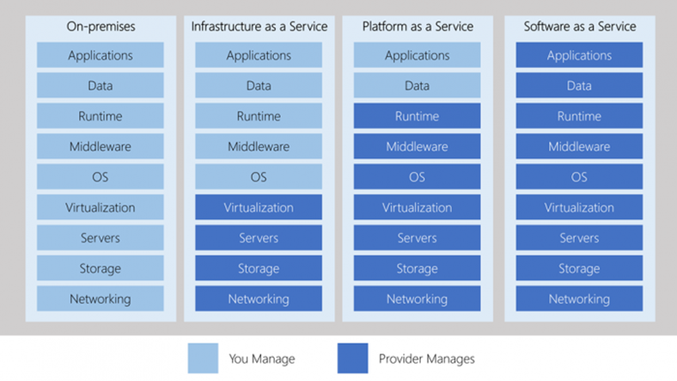

Dynamic Link Library (DLL)
A DLL is a library that contains code and data that can be used by more than one program at the same time.

Virtual Machines
- VMs run on Hypervisors, which allow multiple Virtual Machines to run on a single machine along with its own operating system.
- Each VM has its own copy of an operating system along with the application and necessary binaries, which makes it significantly larger, and it requires more resources.
- They provide Hardware-level process isolation and are slow to boot.

Features of Docker
- It is designed to provide a lightweight and fast environment in which to run our code as well as an efficient workflow to get that code from our laptop to our test environment and then into production.
- Open-source platform
- An easy, lightweight, and consistent way of delivery of applications
- Fast and efficient development life cycle
- Segregation of duties
- Service-oriented Architecture
- Security
- Scalability
- Reduction in Size
- Image management
- Networking
- Volume management

Architecture of Docker
- Docker makes use of client-server architecture.
- The Docker client talks with the docker daemon which helps in building, running, and distributing the docker containers.
- The Docker client runs with the daemon on the same system, or we can connect the

Docker Daemon
- It manages all the services by communicating with other daemons.
- It manages docker objects such as images, containers, networks, and volumes with the help of the API requests of Docker.

Docker Client
- With the help if the docker client, the docker users can interact with the docker.
- The docker command uses the Docker API.
- The Docker client can communicate with multiple daemons.
- When a docker client runs ……….

Docker Host
- A Docker Host is a type of machine that is responsible for running more than one container.
- It comprises the Docker daemons, images, containers, networks, and storage ………

Docker Registry

Docker Objects
Docker Images
- An image contains instructions for creating a docker container.
- It is just a read-only template.
- It is used to store and ship applications.
- Images are an important part of the docker experience as they enable collaboration between developers in any way which is not possible earlier.

Docker Containers
- Containers are created from docker images as they are ready applications.
- With the help of Docker API or CLI, we can start, stop, delete, or move a container.
- A container can access only those resources which are defined in the image unless additional access is defined during the building of an image in the container.

Docker Storage
- We can store data within the writable layer of the container, but it requires a storage driver.
- Storage driver controls and manages the images and containers in our docker host.

Azure Container Services
They are light-weight, virtualized environment that does not require operating system management, and can respond to changes on demand.
- Azure Container Instances
- Azure Container Apps
- Azure Kubernetes Service: An orchestration service for containers with distributed architecture and large volume of containers.

Deploy Azure Container Instances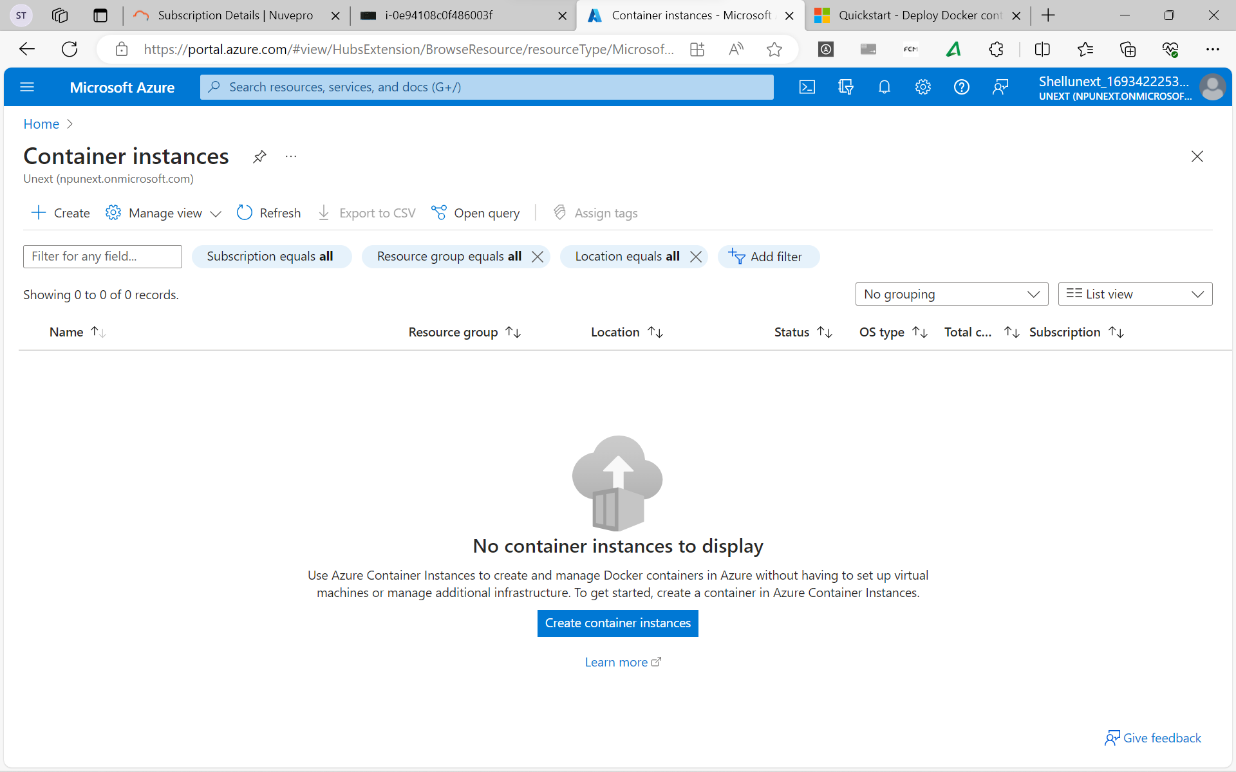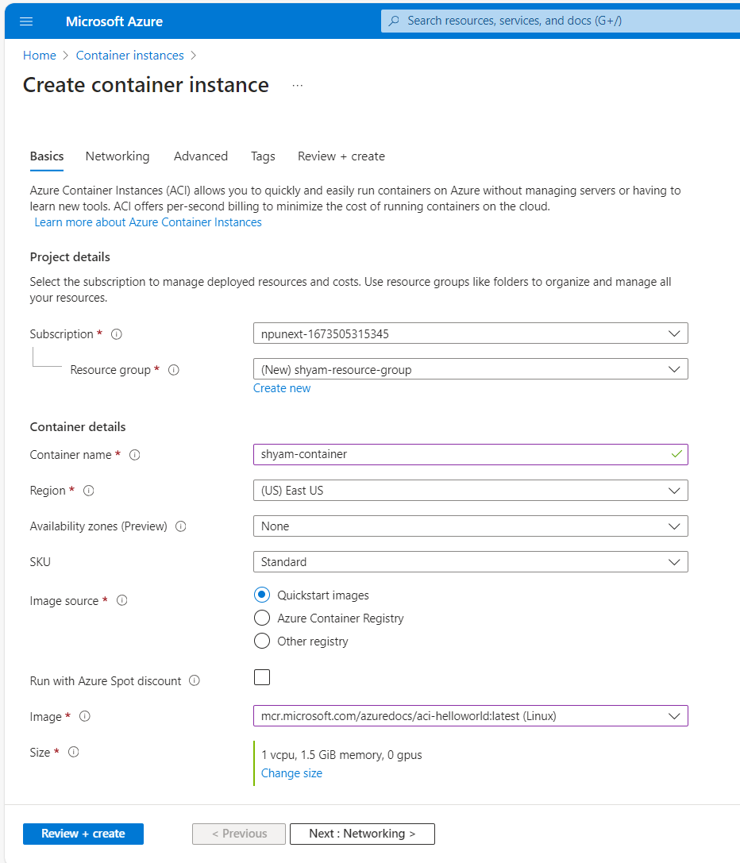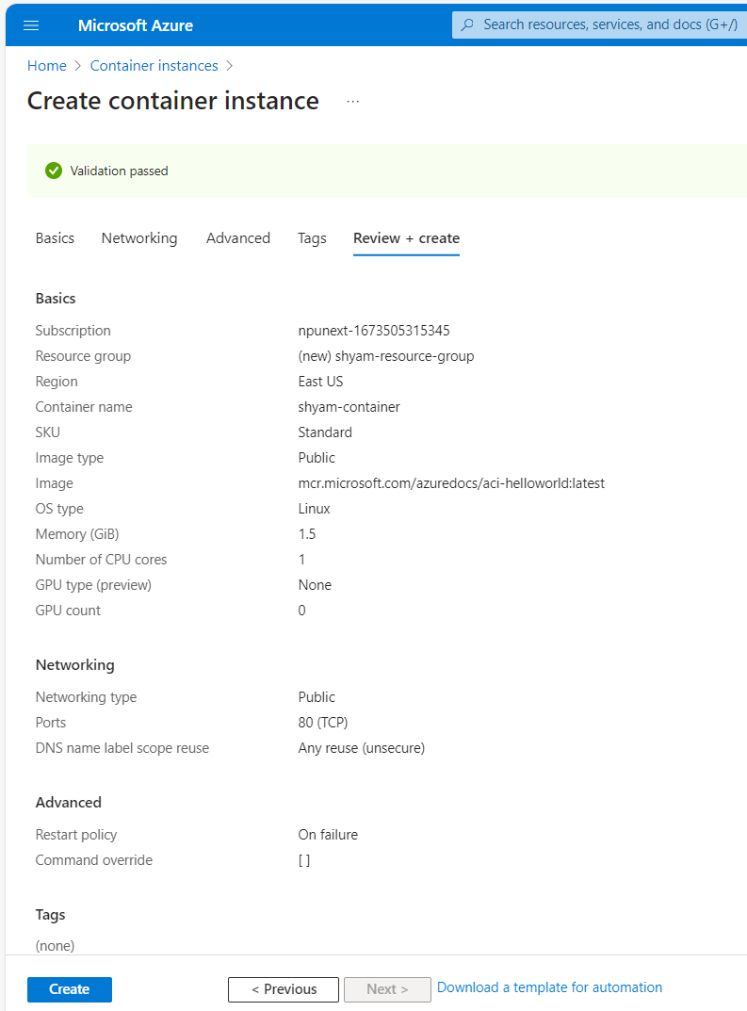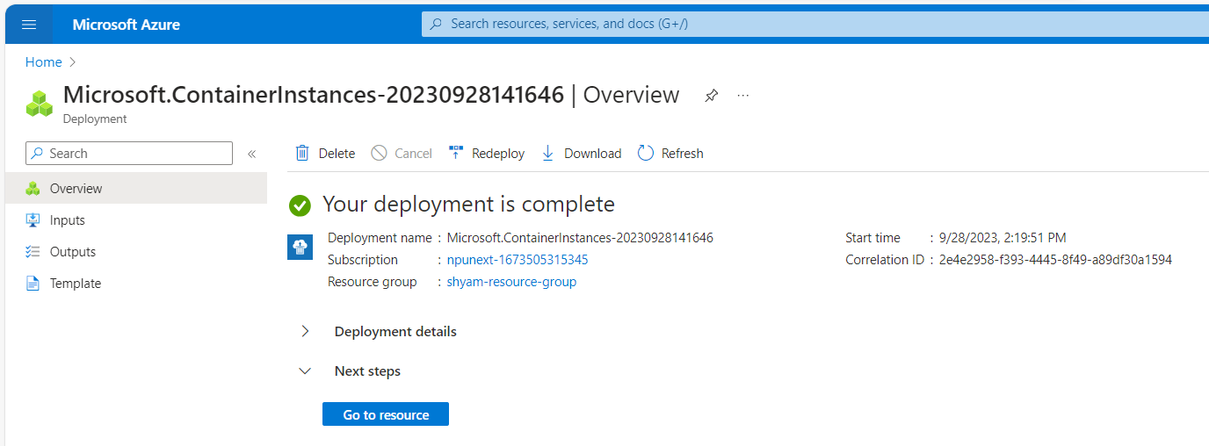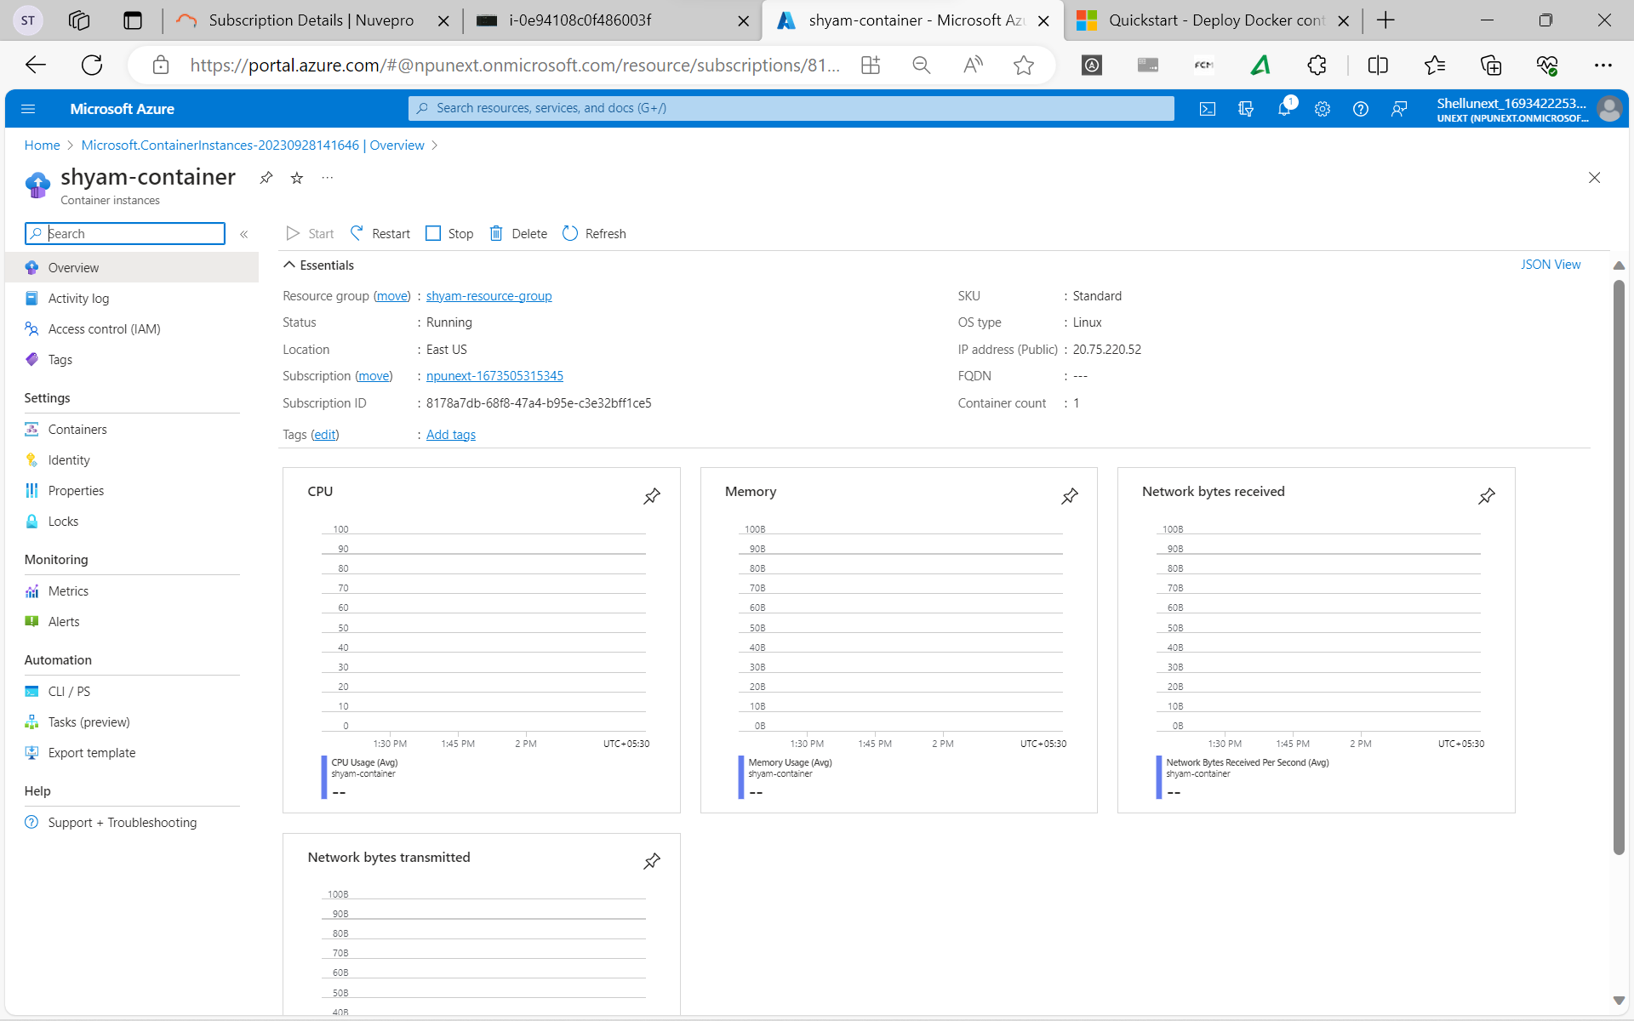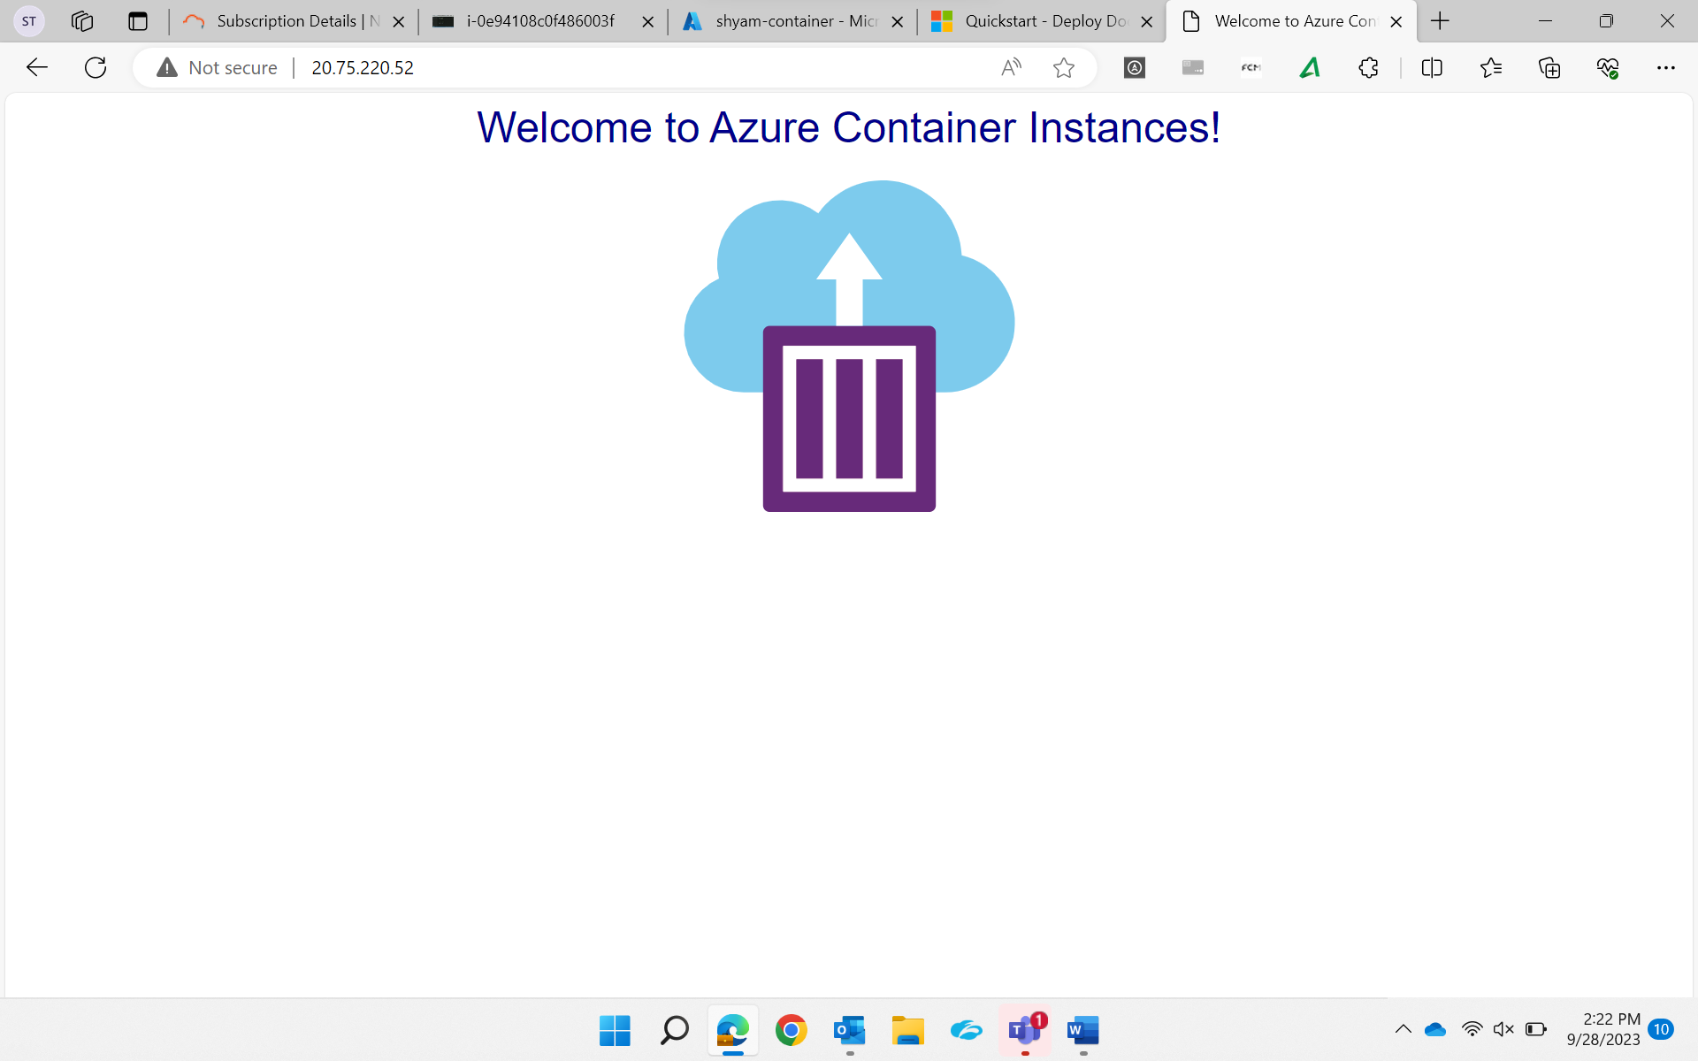

View Container Logs
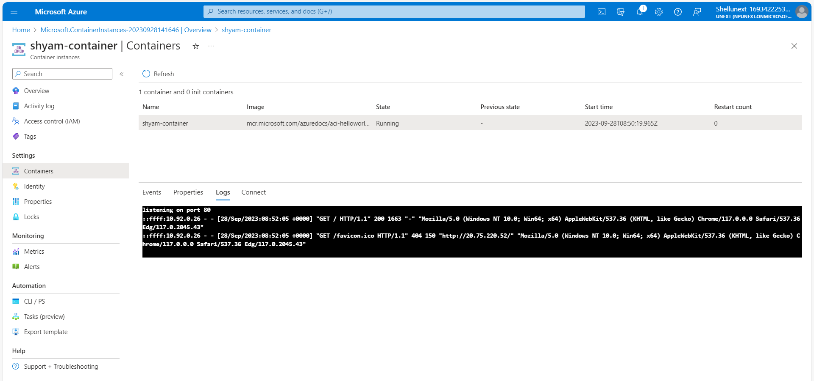

Container Registry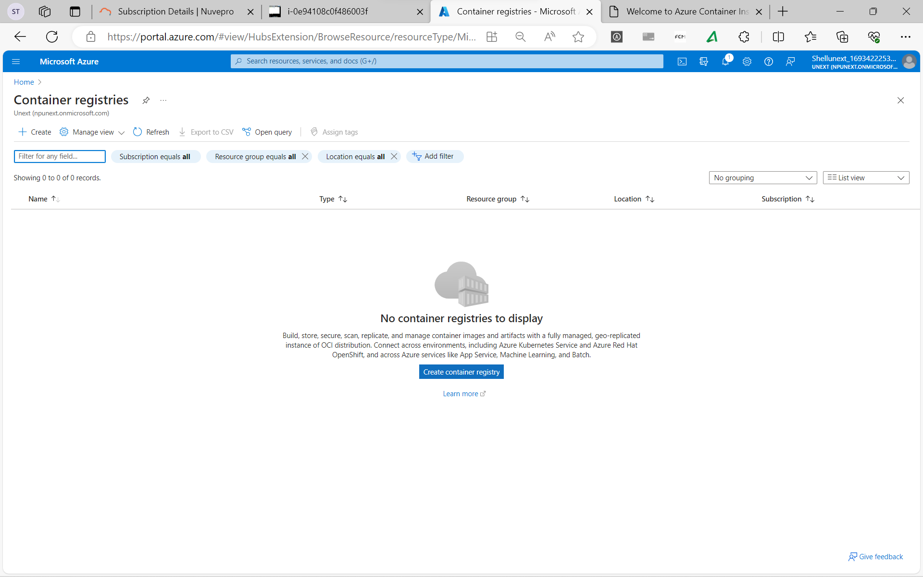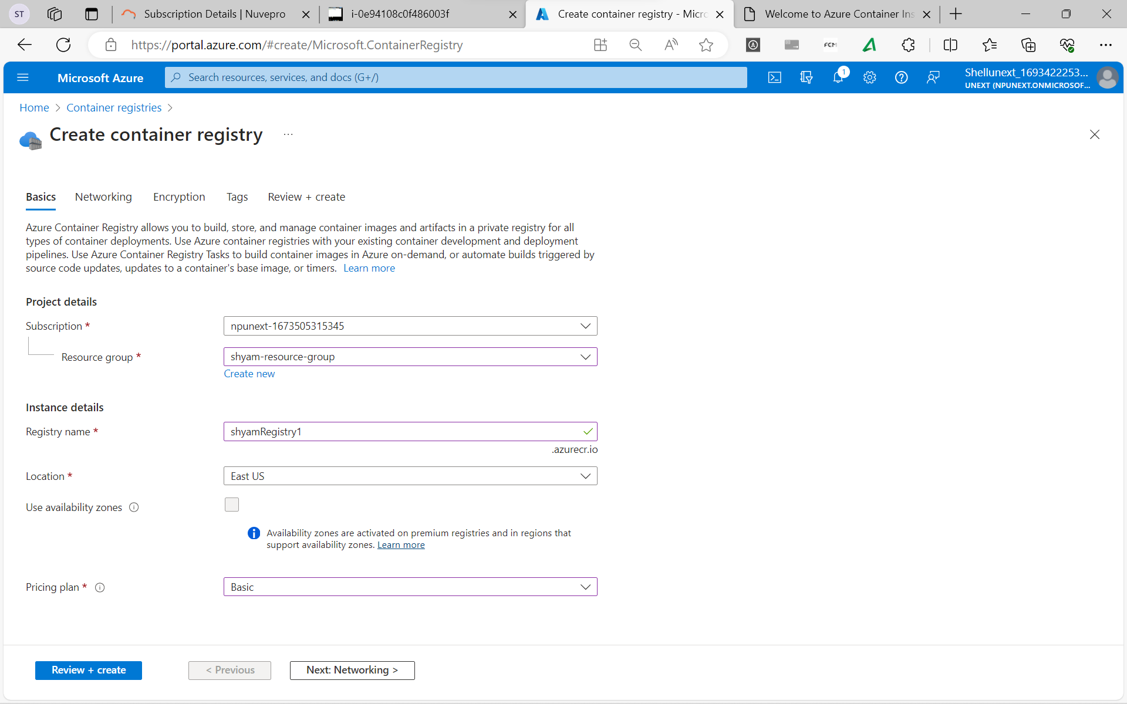
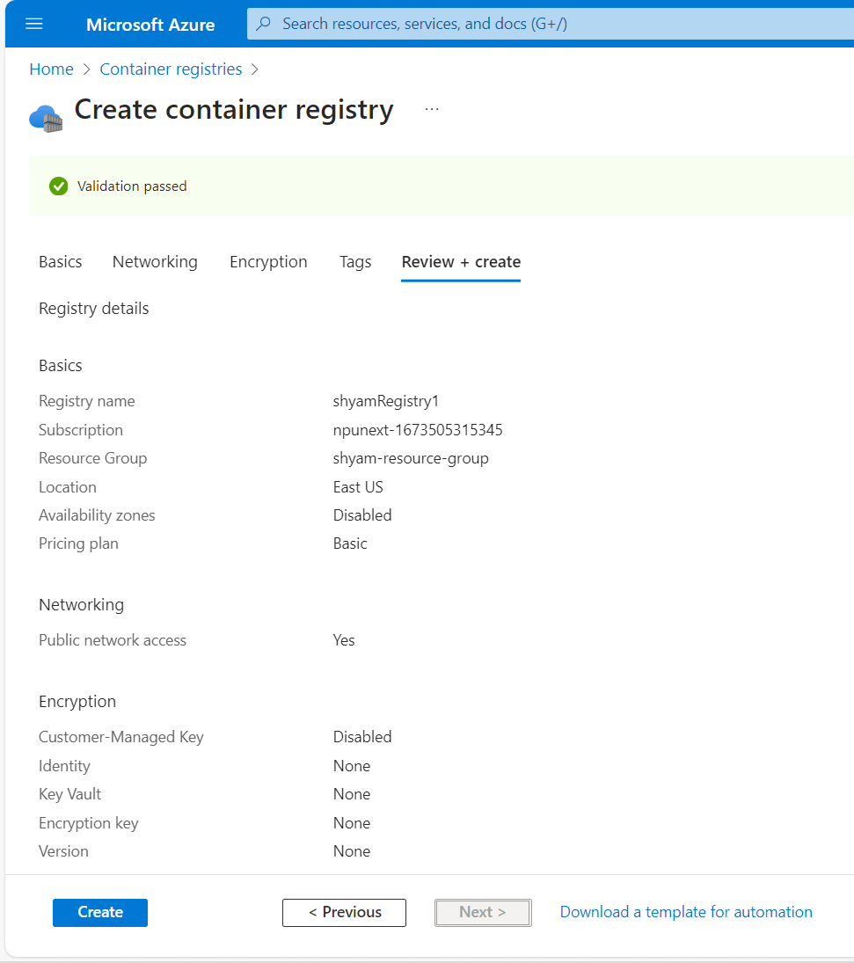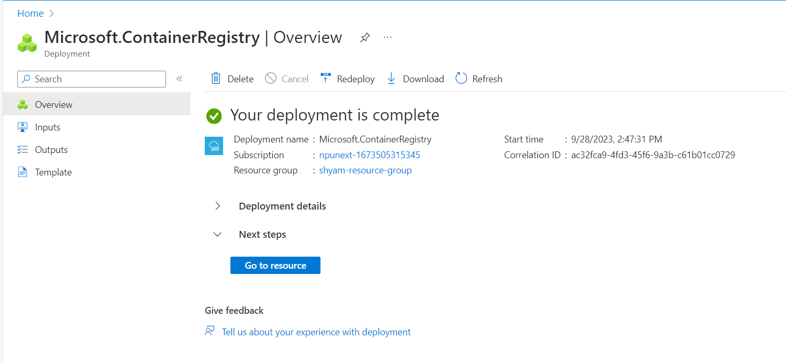

Introduction to Kubernetes
- It is an open-source container management tool that automates container deployment, container scaling, descaling and container load balancing (also called a container orchestration tool).
- It is written in Golang and has a vast community because it was first developed by Google and later donated to CNCF. Kubernetes can group ‘n’ number of containers into one logical unit for managing and deploying them easily.
- Kubernetes is an open-source …….

Features of Kubernetes
- Automating Scheduling: Kubernetes provides an advanced scheduler to launch containers on cluster nodes. It performs source optimization.
- Self-Healing Capabilities: It provides rescheduling, replacing, and restarting the containers which are dead.
- Automated Rollouts and Rollbacks
- Resource Utilization: Kubernetes provides resource utilization monitoring and optimization, ensuring containers are using their resources efficiently.
- Support for Multiple clouds and Hybrid clouds: Kubernetes can be deployed on different cloud platforms and ruin containerized applications across multiple clouds.
- Extensibility: Kubernetes is very extensible and can be extended with custom plugins and controllers.
- Community Support

Architecture of Kubernetes
- Kubernetes follows the client-server architecture which we have the master installed on one machine and the node on separate Linux machines.
- It follows the master-slave model which uses a master to manage Docker containers across multiple Kubernetes nodes.
- A master and its controlled nodes (worker nodes) constitute a Kubernetes cluster.
- A developer can deploy an application in the docker containers with the assistance of the Kubernetes master.

